**Task No. 1:** Get the price of an order (by multiplying unit price by quantity).

**Solution:** select UnitPrice,Quantity,UnitPrice*Quantity as NewPrice from [Order Details]

**Output:**

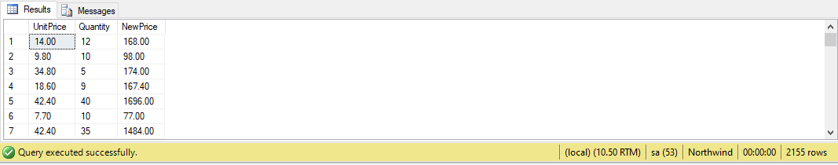

**Task No. 2:** Display all cities that employees belong to but don’t allow repetition.

**Solution:** select distinct City from Employees

**Output:**

**Task No. 3:** Find complete name of all employees.

**Solution:** select FirstName+LastName as 'Full Name' from Employees

**Output:**

**Task No. 4:** List the name of all employees whose first name starts with the letter ‘A’.

**Solution:** select FirstName from Employees where FirstName like 'A%'

**Output:**

**Task No. 5:** In Customer table, display all cities that ends with the letter ‘a’.

**Solution:** select City from Customers where City like '%A'

**Output:**

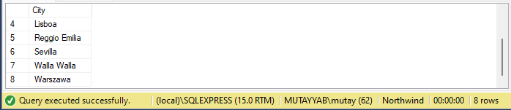

**Task No. 6:** Display names of all employees whose name contain ‘an’.

**Solution:**  select FirstName from Employees where FirstName like '%An%'

**Output:**

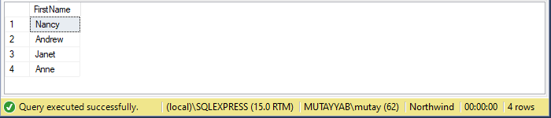

**Task No. 7:** Display all the orders where unit price lies in the range of 10$ to 40$.

**Solution:** select * from [Order Details] where UnitPrice between 10 and 40

**Output:**

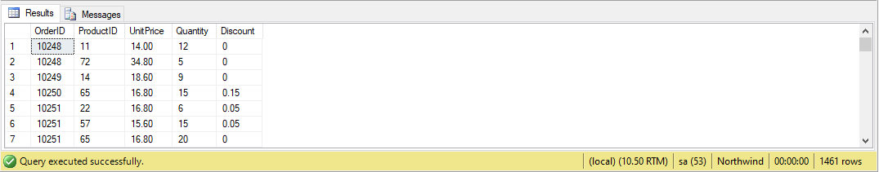

**Task No. 8:** Display the company name where Region is NULL in Customer Table.

**Solution:** select CompanyName from Customers where Region is null

**Output:**

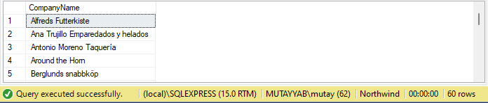

**Task No. 9:** Write a query to list employees whose address does not contain Rd.

**Solution:**  select * from Employees where Address not like '%rd%'

**Output:**

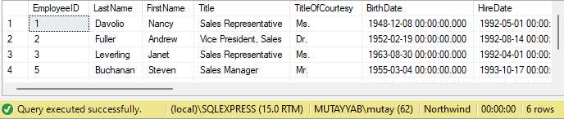

**Task No. 10:** List all products where UnitPrice is not in 10,12,15,17 or 19

**Solution:** select * from Products where UnitPrice not in (10,12,15,17,19)

**Output:**

**Task No. 11:** Display the highest, lowest, sum and average UnitPrice of each Category, where highest UnitPrice lies in the range of 50$ to 100$. Label column as CategoryId, Maximum, Minimum, Sum and Average, respectively. (Table: Products)

**Solution:** select CategoryID,max(UnitPrice) as Maximum,min(UnitPrice) as Minimum,sum (UnitPrice) as [Total Sum],avg(UnitPrice) as [Average] from Products group by CategoryID having max(UnitPrice) between 50 and 100

**Output:**

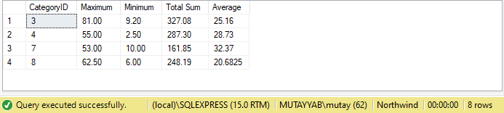

**Task No. 12:** From customers table, Count all customers is each region where region is not null. (Table: Customers)

**Solution:** select count(*) As [All Region] from Customers group by Region

having Region is not null

**Output:**

**Task No. 13:** Write a query to display the number of ContactName with same ContactTitle. Sort contact title in descending order. (Table: Customers)

**Solution:** select ContactName,ContactTitle from Customers order by ContactTitle desc

**Output:**

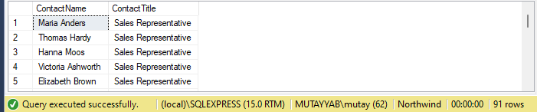

**Task No. 14** **:** Write a query that count all orders against each product id. No of orders should be greater than 50. (Table: [Order Details])

**Solution:** select ProductID, count(OrderID) as [Order] from [Order Details]

group by ProductID having COUNT(OrderID) > 50

**Output:**

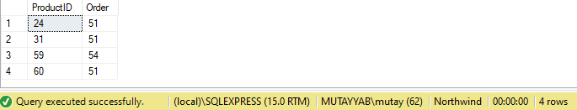

**Task No. 15:** List only those cities in which more than or equals to 2 employees are living

**Solution:** select City,Count(City) as [Number Of Employee Living] from Employees group by City having COUNT(City) >=2

**Output:**

